ITRW 313 - 2018

Math tutoring expert system report

AY PATEL – 27342514

A PRETORIUS - 26056569

Contents

Introduction 2

Discussion of the problem domain 2

Project Discussion 3

CLIPS 3

C# Implementation 3

Execution of tasks in systems development phase 4

Planning 4

Knowledge definition 5

Knowledge design 6

Knowledge design 6

Code and checkout 6

Knowledge Verification 6

System Evaluation 6

Example input, and output given by the system 7

Input example 7

Output example 7

Graphical representation of knowledge used by the system 8

Conclusion 8

Bibliography 10

# Introduction

Expert System – An expert system is a computer program that uses the various technologies of AI to simulate the knowledge and actions of a human that has professional expertise within a unique field. In essence, it uses expert knowledge and inference procedures that would otherwise require an expert.

The expert system project is based on a math tutoring system. The system will be used for young learners in the age cluster of 5 – 10 years old. The main objective of the system is to allow these young learners to improve their mathematical skills. Problems will be based on various operators such as, subtraction, addition, division and multiplication.

The expert system that we have developed works in both CLIPS and in C# with the implementation of CLIPS using the “mommosoft.dll” reference in C#.

# Discussion of the problem domain

The problem domain is set according to the primary school syllabus.

Regarding the primary school syllabus, the young learners must be able to:

* To distinguish between the various arithmetic operators.
* To work with multiple types of exercises (for example, 2 + 7 + 1 + 3).
* To understand how to use the arithmetic operators.

# Project Discussion

The expert system uses code in CLIPS and is composed of an interface designed in C# which is used to graphically illustrate the mathematical tutoring expert system.

# CLIPS

In the CLIPS code, the important foundations are declared. There are multiple slots which are used to declare the operator, difficulty, number of questions, and number of numbers in a question. The user will be prompted to give certain criteria based on four essential questions. These questions include:

- Enter the operator(Add)

- Enter the number of numbers (2, 3 or 4):

- Enter the number of questions (10 or 25):

- Enter the difficulty (Easy or Hard):

Once the users have put in the above criteria, each of the independent defrules will be tested and the appropriate output will be given. Examples of such criteria may be in the form of:

* (Add, 2, 10, Easy) and formatted to - A210QE as a text file
* (Sub, 3, 10, Easy) and formatted to - A210QE as a text file
* (Mult, 2, 25, Hard ) and formatted to - A210QE as a text file
* (Div, 2, 10, Easy) and formatted to - A210QE as a text file

## C# Implementation

The clips code is implemented into C# and the user interface aids in improving user friendliness. During the calculations, users are notified with labels indicating whether they are correct or incorrect. If they are correct it shows the question again as well as the answer. If they are incorrect, it shows the question along with the correct answer.

After the user is done exercising his/her maths skills, they can choose to end the program and a notification will prompt to tell them of their score in that specific exercise that they have carried out. A help button is also available which provides the learner with helpful advice on the logic of the game as well as other information that may be essential for the learner, especially if it is their first time using the mathematical application.

# Execution of tasks in systems development phase

There are several stages in the linear model. The stages include:

* Planning stage.
* Knowledge definition.
* Knowledge design.
* Code and checkout.
* Knowledge verification.
* System evaluation.

These are the 6-stages that are crucial in Expert System development and process.

## Planning

The first stage is known as the planning stage. The main objective of the planning stage is to plan the introduction for the next outcomes of the project, which is used for guidance and evaluation.

To successfully complete the planning stage, we undertook several tasks regarding the feasibility assessment, resource managing, scheduling, obtaining the high-level requirements, getting a preliminary layout and setting out the task phasing.

In terms of doing a ***feasibility assessment***,we decided that the program was valuable since it would be very helpful and rewarding to young students who want to exercise their mathematical skills. Expert knowledge was important since the ability to be successful in mathematics requires great knowledge.

In terms of *resources* we used two experts in the field of education (teachers in primary school). We needed to obtain the “mommosoft.dll” to link the CLIPS code to that in C#. We used two laptops with Microsoft Visual Studio 2015 and CLIPS as the main software types.

***Tasks***include the initial planning, coding the initial solution and then testing and debugging, in that order respectively.

***Schedules****:* The initial planning took place in early March, the coding of the initial solution took place in April and the final testing and debugging took place in May.

***The preliminary functional layout***is the definition of the system functions. The functions in our system were to allow learners to choose which area of mathematics to follow on (addition, subtraction, multiplication or division). The user will select the specific area and then will decide on the difficulty and questions etc. The learner will then be able to get a report on how he/she has performed for that specific exercise. ***High level requirements***include a graphical user interface powered by C# with the implementation of CLIPS code. Radio buttons will be used for the selections and buttons used for the major events such as initializing and finishing the main system process.

## Knowledge definition

The next stage involves defining the knowledge requirements of the expert system currently in production.

There are four important tasks that are applied in the math tutor expert system. They are as follows:

* Source Identification.
* Source Importance.
* Source availability.
* Source selection.

The experts that we used in our system form part of the ***source identification***. Both are qualified teachers in the field – primarily specializing in primary education. These were also our most ***important sources***, who both shared equal value in their expertise. We used several sources in our project, but the main sources were from web sites and documents. With websites topping the list regarding***availability,* *Importance and up-to date information****.*

The ***acquisition strategy***involved us talking to the experts in detail and reading over documentation based on their intuition and valuable expertise. ***Useful knowledge***included the various topics that young learners focus on in school *and* their academic background. In detail the ***function layout***included:

* Radio buttons for allowing the users to effectively navigate around the interface (which was created in C#) and to select the options which will be most applicable to them to learn (addition, subtraction, multiplication and division)
* Buttons to go to the next page or the previous page or to finish the program.
* Deftemplate and deffacts to specify and assign the important slots, such as Operator type (addition, subtraction, division, multiplication etc).

A unique ***control flow***can be observed in the system. The code is loaded from CLIPS and is implemented into C#, where it is manipulated with conventional programming, to provide an interface for executing the various tasks.

## Knowledge design

Important areas include:

* Knowledge definition
* Detailed design

### Knowledge design

The knowledge is *represented* in a graphical user interface.

## Code and checkout

This phase involves the code implementation. Within this phase, you focus on the coding of the solution, various tests are carried out, sources are listed, a user manual guides users. Lastly, a document for describing the system is designed.

## Knowledge Verification

This phase determines the validity and technical aspects of the system in the forms of test analysis and formal testing.

Many reports are used to implement the procedures and to document the test results. Also, these results are further analysed and constructive feedback is given in the form of suggestions and possible recommendations.

## System Evaluation

The final phase is system evaluation whereby the system is evaluated and a basic summary for improvements for the future etc is listed.

The main tasks here include:

* The results evaluation
* Recommendations
* A last report on the details
* Validation and verification

# Example input, and output given by the system

## Input example

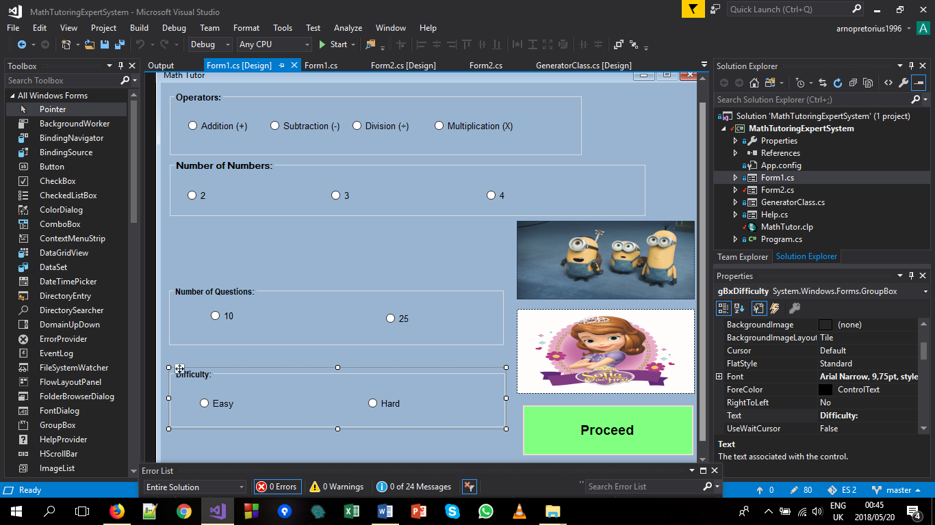

## Output example

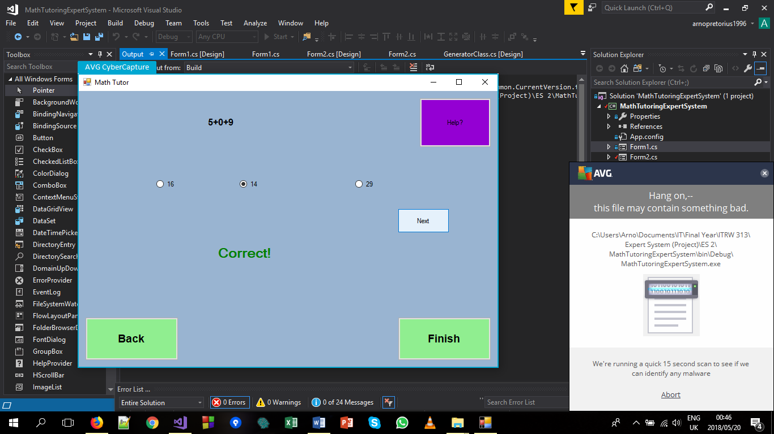

# Graphical representation of knowledge used by the system

# Conclusion

In conclusion the project was a major success. We successfully implemented the CLIPS code with C# and managed to develop CLIPS code that runs independently.

There were many challenges faced along the way. Challenges included:

* Repetition of code.
* Long hours.
* C# implementation.

The first issue was regarding the repetition of code. A lot of code had to be repeated and changed. For example, all the files had a specific format, such as “A210QE, M210QE, A310QH” etc. This in combination with the second issue of long hours, was an obstacle.

In more detail the second issue of spending vast amounts of hours on the code was due to intense research and preparation in making a system math oriented, in a sense of performing calculations, using files to manipulate data and to implement everything together.

The final obstacle that we faced was to implement CLIPS into C#. The main reason for our difficulty was that there was a shortage of past programs, this is possibly due to the reason of CLIPS being dis-continued in the late 1990’s.

However, we learned a lot from the project and in the process, we have gained valuable experience (which far outweighed the challenges) in:

* Team – work.
* Research.
* C# skills.
* CLIPS skills.
* Understanding Expert Systems.

# Bibliography

Www2.cs.siu.edu. (2018). *CLIPS*. [online] Available at: http://www2.cs.siu.edu/~rahimi/cs537/slides/big-2.pdf [Accessed 19 May 2018].

Clipsrules.net. (2018). *CLIPS: A Tool for Building Expert Systems*. [online] Available at: http://www.clipsrules.net/ [Accessed 19 May 2018].

Www1.se.cuhk.edu.hk. (2018). *CLIPS Programming 2*. [online] Available at: http://www1.se.cuhk.edu.hk/~seem5750/CLIPS%202.pdf [Accessed 19 May 2018].